MANAGING RISKS OF PLANT
IN THE WORKPLACE

Code of Practice
SEPTEMBER 2013

Safe Work Australia is an Australian Government statutory agency established in 2009. Safe Work Australia consists of representatives of the Commonwealth, state and territory governments, the Australian Council of Trade Unions, the Australian Chamber of Commerce and Industry and the Australian Industry Group.
Safe Work Australia works with the Commonwealth, state and territory governments to improve work health and safety and workers’ compensation arrangements. Safe Work Australia is a national policy body, not a regulator of work health and safety. The Commonwealth, states and territories have responsibility for regulating and enforcing work health and safety laws in their jurisdiction.

ISBN 978-0-642-33349-0 [PDF]
ISBN 978-0-642-33350-6 RTF]


Creative Commons
Except for the Safe Work Australia logo, this copyright work is licensed under a Creative Commons Attribution-Noncommercial 3.0 Australia licence. To view a copy of this licence, visit
http://creativecommons.org/licenses/by-nc/3.0/au/
In essence, you are free to copy, communicate and adapt the work for non commercial purposes,
as long as you attribute the work to Safe Work Australia and abide by the other licence terms.
Contact information
Safe Work Australia
Phone: 1300 551 832
Email: info@swa.gov.au
Website: www.safeworkaustralia.gov.au
TABLE OF CONTENTS
FOREWORD 4
Scope and application 4
1. INTRODUCTION 5
1.1 The meaning of key terms 5
1.2 Who has health and safety duties in relation to plant at the workplace? 6
1.3 Other persons with duties related to plant 7
1.4 What is required to manage the risks associated with plant? 8
1.5 Registering plant 10
2. THE RISK MANAGEMENT PROCESS 11
2.1 Identifying hazards 11
2.2 Assessing the risks 12
2.3 Controlling risks 13
2.4 Maintaining and reviewing risk control measures 14
3. CONTROLLING RISKS: FROM PURCHASE TO DISPOSAL 16
3.1 Purchasing and hiring plant 16
3.2 Installation and commissioning of plant 19
3.5 Instruction, training and supervision 20
3.4 Using plant in the workplace 20
3.5 Making changes 21
3.6 Inspecting plant 22
3.7 Maintenance, repair and cleaning of plant 23
3.8 Storing plant 24
3.9 Decommissioning, dismantling and disposing of plant 24
4. SPECIFIC CONTROL MEASURES 26
4.1 Guarding plant 26
4.2 Operator controls 31
4.3 Emergency stops 31
4.4 Warning devices 32
4.5 Isolation of energy sources 33
5. PLANT REGISTRATION 36
5.1 Design and altered design registration 36
5.2 Item registration 36
6. KEEPING RECORDS 38
APPENDIX A – REGISTRABLE PLANT 39
APPENDIX B – HAZARD CHECKLIST 42
APPENDIX C – EXAMPLES OF TECHNICAL STANDARDS 45
LIST OF AMENDMENTS 50

FOREWORD
This Code of Practice on managing health and safety risks of plant in the workplace is an approved code of practice under section 274 of the Work Health and Safety (WHS) Act.
An approved code of practice is a practical guide to achieving the standards of health, safety and welfare required under the WHS Act and the Work Health and Safety (WHS) Regulations.
A code of practice applies to anyone who has a duty of care in the circumstances described in the code. In most cases, following an approved code of practice would achieve compliance with the health and safety duties in the WHS Act, in relation to the subject matter of the code. Like regulations, codes of practice deal with particular issues and do not cover all hazards or risks that may arise. The health and safety duties require duty holders to consider all risks associated with work, not only those for which regulations and codes of practice exist.
Codes of practice are admissible in court proceedings under the WHS Act and Regulations. Courts may regard a code of practice as evidence of what is known about a hazard, risk or control and may rely on the code in determining what is reasonably practicable in the circumstances to which the code relates.
Compliance with the WHS Act and Regulations may be achieved by following another method, such as a technical or an industry standard, if it provides an equivalent or higher standard of work health and safety than the code.
An inspector may refer to an approved code of practice when issuing an improvement or prohibition notice.
This Code of Practice has been developed by Safe Work Australia as a model code of practice under the Council of Australian Governments’ Inter-Governmental Agreement for Regulatory and Operational Reform in Occupational Health and Safety for adoption by the Commonwealth, state and territory governments.

Scope and application
This Code provides practical guidance on how to manage health and safety risks of plant once it is in the workplace, from plant installation, commissioning and use through to decommissioning and dismantling.
This Code provides practical guidance to persons who conduct a business or undertaking and have management or control of plant in the workplace, as well as to persons who install and commission plant. It includes information about specific control measures required under the WHS Regulations for plant generally. Other approved codes of practice on various types of plant may also be referenced.
The Code of Practice: Safe design, manufacture, import and supply of plant provides further guidance for persons conducting a business or undertaking involved in these activities.
How to use this Code of Practice
In providing guidance, the word ‘should’ is used in this Code to indicate a recommended course of action, while ‘may’ is used to indicate an optional course of action.
This Code also includes various references to provisions of the WHS Act and Regulations which set out the legal requirements. These references are not exhaustive. The words ‘must’, ‘requires’ or ‘mandatory’ indicate that a legal requirement exists and must be complied with.

1. INTRODUCTION
Plant is a major cause of workplace death and injury in Australian workplaces. There are significant risks associated with using plant and severe injuries can result from the unsafe use of plant including:
- limbs amputated by unguarded moving parts of machines
- being crushed by mobile plant
- sustaining fractures from falls while accessing, operating or maintaining plant
- electric shock from plant that is not adequately protected or isolated, and
- burns or scalds due to contact with hot surfaces, or exposure to flames or hot fluids.
Other risks include hearing loss due to noisy plant and musculoskeletal disorders caused by manually handling or operating plant that is poorly designed.

1.1 The meaning of key terms
Plant includes any machinery, equipment, appliance, container, implement and tool, and includes any component or anything fitted or connected to any of those things. Plant includes items as diverse as lifts, cranes, computers, machinery, conveyors, forklifts, vehicles, power tools and amusement devices.
Plant that relies exclusively on manual power for its operation and is designed to be primarily supported by hand, for example a screw driver, is not covered by the WHS Regulations. The general duty of care under the WHS Act applies to this type of plant.
Certain kinds of plant, such as forklifts, cranes and some pressure equipment, require a licence from the WHS regulator to operate and some high-risk plant must also be registered with the WHS regulator.
Competent person means a person who has acquired through training, qualification or experience the knowledge and skills to carry out the task.
A competent person has a more specific meaning in the following circumstances:
- For design verification, the person must have the skills, qualifications, competence and experience to design the plant or verify the design.
- For inspection of plant for registration purposes the person must have
- educational or vocational qualifications in an engineering discipline relevant to the plant being inspected, or
- knowledge of the technical standards relevant to the plant being inspected.
- For inspection of mobile cranes, tower cranes and amusement devices the person must
  - have the skills, qualifications, competence and experience to inspect the plant, and be registered under a law that provides for the registration of professional engineers (in jurisdictions where such a law exists), or
  - be determined by the WHS regulator to be a competent person.
Fail safe means a state or condition where, if any component or function of the plant fails, a system exists to prevent any increase in the risks. For example, if the primary hoist brake fails on a crane lifting a person in a workbox, the secondary hoist brake will prevent uncontrolled dropping of the workbox. However, once the secondary brake is engaged, a lower level of safety has been reached. The situation must be made safe and the fault rectified so that the fail safe capability is re-established.

1.2 Who has health and safety duties in relation to plant at the workplace?
A person conducting a business or undertaking has the primary duty under the WHS Act to ensure, so far as is reasonably practicable, that workers and other persons are not exposed to health and safety risks arising from the business or undertaking. This duty includes ensuring, so far as is reasonably practicable:
- the provision and maintenance of safe plant, and
- the safe use, handling, storage and transport of plant.
Persons who conduct a business or undertaking involving the management or control of fixtures, fittings or plant at a workplace also have a duty to ensure, so far as is reasonably practicable, that the fixtures, fittings and plant are without risks to the health and safety of any person.
The WHS Regulations include specific duties for persons who conduct a business or undertaking involving the management or control of plant (persons with management or control of plant) including requirements to:
- manage the health and safety risks associated with plant
- prevent unauthorised alterations to or interference with plant, and
- use plant only for the purpose for which it was designed unless the proposed use does not increase the risk to health or safety.
As there are generally a number of people involved with plant during its lifecycle (for example from its design through to its use and eventual disposal), a person can have more than one duty and more than one person can have the same duty at the same time.
For example, if you own and operate plant in your workplace and you decide to modify it yourself, you will have the duties of a designer and manufacturer as well as a person with management or control of plant at the workplace.
If you own the plant, you will be the person with management or control of that plant. If you hire or lease an item of plant, you have management or control of that plant for the period that you have hired it for and will have responsibility for ensuring health and safety together with the person you have hired or leased it from.
If you conduct a business or undertaking that installs, commissions, maintains, operates, tests, repairs or carries out any other activity associated with plant in workplaces, even if you do not own the plant, you will be a person with management or control of the plant. This is because you have a degree of control over the plant during the period of the activity. In these situations you will have responsibility for managing risks associated with the plant together with other duty holders, such as the owner of the plant.
Officers, for example company directors, have a duty to exercise due diligence to ensure that the business or undertaking complies with the WHS Act and Regulations. This includes taking reasonable steps to ensure that the business or undertaking has and uses appropriate resources and processes to eliminate or minimise risks that arise from plant used in the workplace.
Workers have a duty to take reasonable care for their own health and safety and must not adversely affect the health and safety of other persons. Workers must comply with any reasonable instruction and cooperate with any reasonable policy or procedure relating to health and safety at the workplace.

1.3 Other persons with duties related to plant
Designers, manufacturers, suppliers, importers and installers of plant must also ensure, so far as is reasonably practicable, that the plant is without risks to health and safety.

Designers
The safe design of plant plays a critical role in eliminating hazards and risks before plant is introduced in the workplace.
A designer is a person who conducts a business or undertaking that designs, redesigns or alters the design of plant or any part of the plant that is to be used or could reasonably be expected to be used at a workplace.
Designers have a duty to ensure, so far as is reasonably practicable, that the plant is without risks to health and safety to workers throughout the life of the plant. Among other things, designers must also provide specific information to the manufacturer. If the manufacturer advises the designer that there are safety issues with the design, the designer must revise the information to take account of these concerns, or tell the manufacturer in writing the reasons why such revision is not necessary. Designers must also carry out, or arrange the carrying out of, any calculations, analysis, testing or examination that may be necessary to ensure the plant is safe and without risks to health and safety.

Manufacturers
Manufacturers have a duty to ensure, so far as is reasonably practicable, that the plant is manufactured to be without risks to workers throughout the lifecycle of the plant. Manufacturers must advise the designer of any hazards they identify during manufacture and ensure that hazards are not incorporated into the manufacture of the plant.
Manufacturers must also arrange for any calculations, analysis, testing or examination that may be necessary to ensure that the plant is without risks to health and safety. If design registration is required, the manufacturer must give the design registration number to the person with management or control of the plant, who must ensure the number is kept readily accessible.
A reliable way to achieve this is for the manufacturer to permanently mark the design registration number on the plant.

Importers and suppliers
Importers of plant from outside Australia must take all reasonable steps to obtain information from the manufacturer and then pass this information on when supplying the plant. If this is not available importers must carry out, or arrange the carrying out of, any calculations, analysis, testing or examination that may be necessary to ensure, so far as is reasonably practicable, that the plant is without risks to the health and safety of any person. If design registration is required, the importer will also have duties to ensure that the design of plant is registered.
Any imported plant must be inspected, having regard to information provided by the manufacturer. If this information requires the plant to be tested then the importer must undertake this testing.
If an importer identifies any hazards, the importer must not supply the plant until the risks have been eliminated, or minimised, so far as is reasonably practicable, or if that is not possible, advise the person receiving the plant of those risks.
If the item of plant requires any alteration as a result of testing or hazard identification, then the importer must take all reasonable steps to advise the designer and manufacturer of this.
Suppliers of second-hand plant must ensure, so far as is reasonably practicable, that any faults in the plant are identified. A written notice outlining the condition of the plant, any faults identified and, if appropriate, that the plant should not be used until the fault is rectified must be provided to the person to whom the plant is supplied.
If second-hand plant is to be used for scrap or spare parts, the supplier must inform the person they are supplying the second-hand plant to that the plant is being supplied as scrap or spare parts and that the plant in its current form is not to be used as plant. This must be done in writing or by marking the item of plant.
Further information is available in the Code of Practice: Safe design, manufacture, import and supply of plant.

Installers
An installer is a person who conducts a business or undertaking who sets up, assembles, places in position and connects or otherwise makes plant ready for use. Installers have certain duties under the WHS Regulations (see Section 3.2 of this Code).

1.4 What is required to manage the risks associated with plant?
Regulation 203: A person with management or control of plant at a workplace must manage risks to health and safety associated with the plant.
Regulation 34-38: In order to manage risk under the WHS Regulations, a duty holder must:
- identify reasonably foreseeable hazards that could give rise to the risk
- eliminate the risk so far as is reasonably practicable
- if it is not reasonably practicable to eliminate the risk, minimise the risk so far as is reasonably practicable by implementing control measures in accordance with the hierarchy of control
- maintain the implemented control measure so that it remains effective, and
- review, and if necessary revise, risk control measures so as to maintain, so far as is reasonably practicable, a work environment that is without risks to health and safety.
This Code provides guidance on how to manage the risks associated with plant in the workplace by following a systematic process that involves:
- identifying hazards
- if necessary, assessing the risks associated with these hazards
- implementing and maintaining risk control measures, and
- reviewing risk control measures.
Guidance on the general risk management process is available in the Code of Practice: How to manage work health and safety risks.

Providing and obtaining information
Designers, manufacturers, importers and suppliers all have duties to provide information about the plant to enable other duty holders to fulfil the responsibilities they have in managing the risks associated with it. This information must be given to each person to whom the plant (or its design) is provided. Information must be passed on from the designer through to the manufacturer and supplier to the end user. This information includes:
- the purpose for which plant was designed or manufactured
- the results of any calculations, analysis, testing or examination, and
- any conditions necessary for the safe use of the plant.

Consulting workers
Consultation involves sharing of information, giving workers a reasonable opportunity to express views and taking those views into account before making decisions on health and safety matters.
Section 47: The WHS Act requires that you consult, so far as is reasonably practicable, with workers who carry out work for you who are (or are likely to be) directly affected by a work health and safety matter.
Section 48: If the workers are represented by a health and safety representative, the consultation must involve that representative.
Consultation with workers and their health and safety representatives is required at each step of the risk management process.
Your workers usually know the hazards and risk associated with the plant they use. By drawing on the experience, knowledge and ideas of your workers you are more likely to identify all hazards and develop effective risk controls.
It is important to consult your workers as early as possible when planning to introduce new plant or change the way plant is used.

Consulting, co-operating and co-ordinating activities with other duty holders
There may be other businesses involved with plant at your workplace, for example who carry out installation or repair, or who share the workplace with you.
Section 46: The WHS Act requires that you consult, co-operate and co-ordinate activities with all other persons who have a work health or safety duty in relation to the same matter, so far as is reasonably practicable.
For example, if you own or manage an on-hire business and your workers undertake work at other workplaces then you should exchange information with the host business to determine:
- if your workers could be exposed to hazardous plant, and
- what each of you will do to control any associated risks.
If you use plant (for example mobile plant such as a forklift) at a workplace that is shared with other businesses you should talk to those businesses about the risks your plant could cause them and work together in a co-operative and co-ordinated way to manage the risks.
Further guidance on consultation requirements is available in the Code of Practice: Work health and safety consultation, co-operation and co-ordination.

1.5 Registering plant
Certain items of plant and types of plant designs must be registered. A list of registrable plant is provided at Appendix A.
Registrable plant must be:
- design registered before it is supplied, and
- item registered before it is used.

Design registration
Design registration is the registering of a completed design, from which any number of individual items can be manufactured. The person applying for design registration may be either the original designer or a person with management or control of the item of plant.

Item registration
Plant item registration applies to a specific item of plant and each item requires registration. The purpose of registering an item of plant is to ensure that it is inspected by a competent person and is safe to operate. It is the responsibility of the person with management or control of plant to ensure that all registrable plant items are registered.
Further information on registering plant is provided in Chapter 5 of this Code.

2. THE RISK MANAGEMENT PROCESS

2.1 Identifying hazards
Identifying hazards involves finding all of the things and situations that could potentially cause harm to people. Hazards associated with plant generally arise from:
- The plant itself, for example hazards associated with a forklift would include hazards relating to its mobility, its electrical, hydraulic and mechanical power sources, moving parts, load-carrying capacity and operator protection.
- How and where the plant is used. The forklift, for example may have hazards arising from the kind of loads it is used to lift, the size of the area in which it is used and the slope or evenness of the ground.

Inspect the plant
Inspect each item of plant in your workplace and observe how it is used. Talk to your workers and their health and safety representatives to find out what their experience is with the plant they operate, inspect or maintain.
If you have hired or leased plant, you should also consult the person who owns the plant about potential hazards, because you both have responsibility for ensuring that the plant is safe and without risk to health and safety.
When identifying hazards you should think about all the activities that may be carried out during the life of the plant at your workplace, such as: installation, commissioning, operation, inspection, maintenance, repair, transport, storage and dismantling. For each of these activities, you should consider whether the plant could:
- cause injury due to entanglement, falling, crushing, trapping, cutting, puncturing, shearing, abrasion or tearing
- create hazardous conditions due to harmful emissions, fluids or gas under pressure, electricity, noise, radiation, friction, vibration, fire, explosion, moisture, dust, ice, hot or cold parts, and
- cause injury due to poor ergonomic design, for example if operator controls are difficult to reach or require high force to operate.
Other factors to consider include:
- the condition of the plant, for example its age, its maintenance history and how frequently the plant is used.
- the suitability of the plant, for example is it actually being used for its intended purpose?
- the location of the plant, for example what is its impact on the design and layout of the workplace and are workers able to access the plant without risk of slips, trips or falls?
- abnormal situations, for example what abnormal situations, misuse or fluctuation in operating conditions can you foresee?
A checklist to assist in identifying hazards associated with plant is at Appendix B.

Review safety information
Information about hazards, risks and control measures relating to plant in your workplace can be obtained from:
- manufacturers, importers or suppliers of the plant
- maintenance technicians or specialists such as engineers
- your workers
- WHS regulators, unions and other organisations
- businesses or undertakings similar to your own, and
- technical standards.

Review incident records and data
Check your records of workplace injuries and illness, dangerous incidents, plant inspection reports and maintenance logs, workers’ compensation records and the results of any investigations to collect information about plant hazards.

2.2 Assessing the risks
A risk assessment involves considering what could happen if someone is exposed to a hazard combined with the likelihood of it happening. A risk assessment can help you determine:
- how severe a risk is
- whether existing control measures are effective
- what action you should take to control the risk, and
- how urgently the action needs to be taken.
A risk assessment is unnecessary if you already know the risk and how to control it.
To assess the risk associated with plant hazards you have identified, you should consider the following:

What is the potential impact of the hazard?
- How severe could an injury or illness be? For example, lacerations, amputation, serious or fatal crushing injury, burns or loss of hearing.
- What is the worst possible harm the plant hazard could cause?

How likely is the hazard to cause harm?
- Is it highly likely or unlikely to happen?
- How frequently are workers exposed to the hazard? For example, if plant is used constantly with five operators per shift and three 8-hour shifts and there is a lack of high level control measures, the risk will increase compared to the occasional use by a single operator.
Other factors to consider when undertaking a risk assessment include:
- In what type of conditions is the plant used in (for example in a confined space, muddy or dusty environment)?
- What is the condition of the plant? For example, is it old and missing safety features found on new plant? Is it reliable or often needing emergency maintenance?
- If there are other people or items of plant in the vicinity, what effect do they have on the likelihood or consequence?
- Where and when is access required during the installation, operation or maintenance of plant and in an emergency?
- What work practices and procedures exist in relation to plant safety (for example isolation to carry out maintenance, emergency shut-down)?
- What kind of training, information, instruction and supervision is provided to workers and other persons who may be exposed to plant?
- Does the plant’s safety depend on the competency of its operators?
- How is work organised? For example
  - the speed of the process line
  - pedestrian and vehicular traffic around the plant
  - time spent on repetitive tasks
  - shift work arrangements, and
  - any production incentives that may affect health and safety.

2.3 Controlling risks
The ways of controlling risks associated with plant are ranked from the highest level of protection and reliability to the lowest. This ranking is known as the hierarchy of risk control. The WHS Regulations require duty holders to work through this hierarchy to choose the control that most effectively eliminates or, where that is not reasonably practicable, minimises the risk in the circumstances. Specific controls are required under the WHS Regulations for certain types of plant, such as:
- powered mobile plant
- plant that lifts or suspends loads
- industrial robots
- lasers
- pressure equipment, and
- scaffolds.

The hierarchy of control measures
Elimination – The most effective control measure is to remove the hazard or hazardous work practice associated with the plant. For example, buy pre-sawn timber instead of using a power saw.
Many hazards can be addressed before introducing plant into your workplace, that is, in the planning and purchasing stages. For example, purchasing machinery that is designed and built to produce low noise levels is more effective than providing workers with personal hearing protectors. This also avoids costly modifications to plant after it is purchased.
If elimination is not reasonably practicable, you must minimise the risk by:
Substitution – Substitute the plant (or hazardous parts of it) with plant that is safer. For example:
- using a cordless drill instead of an electric drill if the power cord is in danger of being cut.
Isolation – separate the hazardous plant from people, either by distance or physical barrier. For example:
- constructing a booth from which the plant can be operated remotely, and
- using concrete barriers to separate mobile plant from workers.
Engineering controls – Include modifications to tools or equipment, for example installing guards to prevent contact with moving parts of machinery or installing a roll over protective structure on a tractor.
Administrative controls – If risk remains, it must be minimised by implementing administrative controls, so far as is reasonably practicable, for example installing a tag-out system to ensure that workers are aware that the plant is isolated from its power source and must not be operated while maintenance or cleaning work is being done. Providing training and supervision, using warning signs or arranging work to minimise the time spent near noisy machinery are all examples of administrative controls.
Personal protective equipment (PPE) – Any remaining risk must be minimised with suitable PPE, such as providing workers with breathing protection, hard hats, gloves, aprons and protective eyewear.
Administrative control measures and PPE rely on human behaviour and supervision, and used on their own, tend to be least effective in minimising risks.

Combining control measures
In many cases, a combination of control measures will provide the best solution. For example, protecting workers from flying debris when using a concrete cutting saw may involve guarding the blade, isolating the work area and using PPE such as a face shield.

2.4 Maintaining and reviewing risk control measures
Regulation 37: Control measures must be maintained so that they continue to protect workers and other people from the hazards associated with plant. The control measures must be:
- fit for purpose
- suitable for the nature and duration of the work, and
- installed, set up and used correctly.
Regulation 38: A person conducting a business or undertaking must review and as necessary revise control measures:
- when the control measure is not effective in controlling the risk
- before a change at the workplace that is likely to give rise to a new or different health and safety risk that the control measure may not effectively control
- if a new hazard or risk is identified
- if the results of consultation indicate that a review is necessary, and
- if a health and safety representative requests a review
The control measures that are implemented must be reviewed and, if necessary, revised to make sure they work as planned and that no new hazards have been introduced by the control measures.
You should consult your workers to obtain feedback on the plant and work processes being used and consider the following questions:
- Are the relevant workers aware of the control measures and do they understand them?
- Are the control measures, for example guards, working effectively in both their design and operation?
- Have all hazards associated with the plant been identified?
- Has the purchase of a new item of plant made the job safer?
- Are safety procedures being followed?
- Has an incident occurred in relation to the plant?
- If new legislation or new information becomes available, does it indicate current controls may no longer be the most effective?
When deciding how frequently to carry out a review, you should consider the level of risk (high risk plant may need more frequent review) and the type of plant involved (there may be particular stages in the life of the plant where a more frequent review is needed).

3. CONTROLLING RISKS: FROM PURCHASE TO DISPOSAL

3.1 Purchasing and hiring plant
Many injuries and illnesses associated with plant occur due to a failure to select the right equipment for the job. Before you purchase plant, check that it is suitable for the intended use including the environment it will be used in and the workers using it. Discuss your needs with the plant supplier, who must provide you with information about:
- the purpose for which the plant was designed or manufactured
- the results of any calculations, analysis, testing or examination
- any conditions necessary for the safe use of the plant, and
- any alterations or modifications made to the plant.
Before purchasing, hiring or leasing plant you should also determine:
- the hazards and risks associated with installation, commissioning, operation, inspection, maintenance, repair, transport, storage and dismantling of the plant
- control measures needed to minimise these hazards and risks
- the manufacturer’s recommendations in relation to the frequency and type of inspection and maintenance needed
- any special skills required for people who operate the plant or carry out inspection and maintenance
- any special conditions or equipment required to protect the health and safety of people carrying out activities such as installation, operation and maintenance, and
- any alterations or modifications to be made to the plant.
You should check whether the plant includes some or all of the following characteristics:
- contact with or access to dangerous parts is prevented, for example by using guards and protective structures
- it is of sturdy construction and has tamper-proof design
- there are no obstructions to the plant operator
- it has fail safe operation
- it is easy to inspect and maintain
- it does not introduce other hazards (for example manual handling problems or excessive noise) into your workplace, and
- it incorporates measures to minimise risks during use (for example low noise).

Purchasing second-hand plant

Second-hand plant
Regulation 198: A supplier of plant must:
- take all reasonable steps to obtain the information required to be provided by the manufacturer under section 23(4)(a) and (c) of the Act and these Regulations, and
- when the plant is supplied, ensure the person to whom the plant is supplied is given the information obtained by the supplier.
Regulation 199: A supplier of second-hand plant must ensure, so far as is reasonably practicable, that any faults in the plant are identified.
Before plant is supplied, the supplier of second-hand plant must ensure that the person to whom the plant is supplied is given written notice of:
- the condition of the plant
- any faults identified, and
- if appropriate, that the plant should not be used until the faults are rectified.
Regulation 8: A supply of a thing does not include the supply of a thing by a person who does not control the supply and has no authority to make decisions about the supply, for example an auctioneer without possession of the thing or a real estate agent acting in their capacity as a real estate agent.
Suppliers’ duties apply whether the plant is new, second-hand or hired out.
Some examples of suppliers include a person conducting a business or undertaking who:
- sells second-hand plant at a retail outlet or directly sells their own second-hand plant
- imports second hand plant for on-sale, and
- auctions second-hand plant, excepting certain clearing sales (see below).
Suppliers’ duties apply to suppliers that know, or should know, the plant is to be used in
a workplace.
Suppliers’ duties apply to a person conducting a business or undertaking whether the sale
is a one-off sale or forms part of the business’ day-to-day operations.

Duty to supply safe plant
Suppliers of second-hand plant must ensure, so far as is reasonably practicable, that the plant it without risks to the health and safety of persons who use it or may be exposed to it.
This includes, so far as is reasonably practicable, identifying any faults in the plant.
Suppliers of second-hand plant, other than scrap or spare parts, must give written notice to
a prospective buyer of:
- the condition of the plant, including identified faults, if any, and
- if appropriate, that the plant should not be used until the faults are rectified.
Suppliers of second-hand plant must also take all reasonable steps to obtain information about how to use the plant correctly and safely from the manufacturer or original supplier.
Suppliers of second-hand plant must give the buyer:
- this information, and
- all available records of the plant that were kept by the previous owner.
The information may include data sheets, test certificates, operations and service manuals, reports and a safety manual.
Out-dated or non-existent safety features of second-hand plant
Second-hand plant is more likely to have out-dated or missing safety features.
In these circumstances suppliers of second-hand plant must do what is reasonably practicable to supply equipment that is safe for use at work.
The degree of risk posed by the plant must be weighed up against the cost of implementing measures to minimise it. Suppliers of second-hand plant should consider:
- if it is reasonably practicable to retrofit or modify the plant to improve its safety having regard to improvements to that type of plant since its manufacture, and
- if not reasonably practicable—whether information needs to be given to the buyer about any relevant matters including the purpose for which the plant was designed or manufactured and any conditions necessary to ensure the plant is without risks to health and safety when properly used.
Buyers also have a duty to ensure the plant is safe and has all the required safety features before bringing it into service.

Adequate information to be provided about the condition of second-hand plant
Adequate information must be given to the buyer about the purpose for which the plant was designed or manufactured and any conditions necessary to ensure its safe use.
Apart from the manufacturer or original supplier—information about using second-hand plant safely, including its condition, may be obtained from:
- the previous owner of the plant, or
- a ‘competent person’ engaged to assess the plant and develop this information.
Without this kind of information, suppliers of second-hand plant have no way of knowing whether they have met their suppliers’ duties under the Act.

Suppliers’ duties and agents or auctioneers selling used agricultural plant at clearing sales
Supplies’ duties apply to sellers’ agents like auctioneers, unless the agent does not take control of the supply and has no authority to make decisions about the supply.
Agents selling used agricultural plant at clearing sales do not take possession of the plant, have little or no control of the supply and are not considered to be suppliers.
In these limited circumstances the suppliers’ duties will only apply to the seller—not their agent.

Supplying scrap and spare parts
Plant sold for scrap or spare parts are not intended to be used at a workplace so does not need to be made safe or supplied with instructions for use.
However the supplier must tell prospective buyers that the plant is being supplied for scrap or spare parts only and that it cannot be used safely in its current form for any other purpose.
This should be done in writing or by marking the item of plant.

Hiring plant
When you hire plant, both you and the person you have hired it from must ensure, so far as is reasonably practicable, that the plant is safe to use. During the time that the plant is in your possession you will have control over the way the plant is used in the workplace.
Before you hire the plant you should assess whether the plant is suitable for its intended use. You should also check that the plant has been inspected and maintained by the supplier according to the manufacturer’s specifications. This may involve checking the log book or maintenance manual. You should also ensure that the supplier provides you with the manufacturer’s information about the purpose of the plant and its proper use.
Any person who hires or leases plant to others will have duties as a supplier of plant and as a person with management or control of plant. This means that they must ensure, so far as is reasonably practicable, that the plant is safe to use and properly maintained. They must also provide specific information with the plant about how to operate it safely.
In most cases the supplier will be responsible for inspecting and maintaining the plant. However, if the plant is to be hired for an extended period of time, you and the supplier may develop arrangements to ensure that the plant is adequately inspected and maintained throughout the lease. This may involve the supplier coming to your workplace to maintain the plant, or you maintaining the plant while it is at your workplace.
The arrangements you make will depend on your ability to inspect and maintain the plant in accordance with the manufacturer’s specifications. If you choose to maintain the plant yourself during the lease, you should provide all information and records about the maintenance to the hirer at the end of the lease.

3.2 Installation and commissioning of plant
Regulation 204: A person with management or control of plant at a workplace must ensure that:
- plant is not commissioned unless the person has established that the plant is, so far as reasonably practicable, without risks to the health and safety of any person
- the person installing or commissioning the plant is a competent person, and is provided with all the information necessary to minimise risks to health and safety, and
- the processes for the installation, construction and commissioning of plant include inspections that ensure, so far as is reasonably practicable, the risks are monitored.

Installing plant
An installer should ensure:
- plant is erected or installed in having regard to the manufacturer’s instructions including ensuring that specialised tools, jigs and appliances necessary to minimise any risk of injury during installation are used
- access to and egress from plant complies with relevant standards
- plant is stable during installation
- the interaction of plant with people, work processes and other plant is considered
- environmental factors affecting installation and use (e.g. wet conditions) are considered, and
- all electrical installations associated with plant comply with AS 3000 (also known as the Australian/New Zealand Wiring Rules) as far as it is relevant.
The installer should notify the designer, manufacturer, supplier and/or the person with management or control of plant of any new risks identified during the installation of the plant.

Positioning plant in the workplace
Plant should be positioned so that:
- risks from hot plant (such as friction, molten material, hot gases) are controlled through restricted access, guarding or insulation
- there is sufficient space (suggested 600 mm, the minimum width of a walkway) for safe access to the plant for operation, cleaning, maintenance, inspection and emergency evacuation
- the plant does not obstruct doorways and emergency exits
- the proximity to other plant does not have a negative effect on the operation of the plant or work processes
- the plant rests on a suitable foundation where required—for example on a floor or other support that ensures the plant is stable and secure
- ventilation is adequate to deal with the nature and volume of any emissions from the plant, and
- workers and others are not exposed to noise levels greater than those stated in the exposure standard for noise under the WHS Regulation.

Commissioning plant
Commissioning plant involves performing the necessary adjustments, tests and inspections to ensure plant is in full working order to specified requirements before the plant is used. Commissioning includes recommissioning.
The person who commissions plant should ensure that:
- the commissioning sequence is in accordance with the design specifications, and
- tests, such as dummy runs, are carried out to check that the plant will perform within the design specifications.

3.5 Instruction, training and supervision
Before plant is used in your workplace, you must provide your workers and other persons who are to use the plant with information, training, instruction or supervision that is necessary to protect them from risks arising from the use of the plant.
You must also provide the necessary safety information to persons who are involved in installing, commissioning, testing, maintaining or repairing plant, as well as decommissioning, dismantling or disposing of plant. This should include information on the types of hazards and risks the plant may pose to the person when they are carrying out these activities.
This information may be supported with safe work procedures that include instructions on:
- the correct use of guarding and other control measures
- how to safely access and operate the plant
- who may use an item of plant, for example only authorised or licensed operators
- how to carry out inspections, shut-down, cleaning, repair and maintenance
- traffic rules, rights of way, clearances and no-go areas for mobile plant, and
- emergency procedures.
Any emergency instructions relating to an item of plant should be clearly displayed on or near it.
Training programs should be practical and ‘hands on’ and take into account the particular needs of workers, for example literacy levels, work experience and specific skills required for safe use of the plant.
Supervisors should take action to correct any unsafe work practices associated with plant as soon as possible, otherwise workers may think that unsafe work practices are acceptable.

3.4 Using plant in the workplace
Regulation 205-206: A person with management or control of plant at a workplace must:
- so far as is reasonably practicable, prevent unauthorised alterations to or interference with the plant
- take all reasonable steps to ensure the plant is only used for the purpose for which it is designed, unless a competent person has assessed that the proposed use does not increase the risk to health and safety, and
- ensure all safety features, warning devices, guarding, operational controls, emergency stops are used in accordance with instructions and information provided.
Workers who operate plant should be competent, or suitably supervised during training, so that they do not put themselves or others at risk. It is important to retain all operating manuals and instructional material provided by the manufacturer in order to correctly operate and maintain the plant once it is in the workplace. You should also consider and address the risks that may arise from:
- operator fitness for work, for example fatigue
- carrying out routine or repetitive tasks, and
- local conditions and working procedures.

High risk work licences
Certain types of plant, such as industrial lift trucks and some types of cranes, require the operator to have a high risk work licence before they can operate the plant. Schedule 3 of the WHS Regulations sets out the classes of high risk work licences and the types of plant involved.

3.5 Making changes
If you intend to alter the design of the plant, change the way the plant is used or change a system of work associated with the plant, you should carry out the risk management process again.
If you intend to use plant in a different way or for a purpose that it was not designed for, you must ensure that the risks associated with the new use are assessed by a competent person. For example, if an item of plant that is designed to cut wood is intended to be used to cut metal, all hazards associated with that use must be identified and the appropriate controls implemented. This may mean the provision of a lubricating and/or cooling fluid system to ensure that the cutting process does not generate excess friction or heat.
The competent person’s assessment should:
- include all aspects of the proposed task
- outline the reasons a purpose-designed item of plant cannot be used for the proposed task, such as the impracticability of using it or additional risks that using purpose-designed plant would generate
- take into account the recommendations of the designer, manufacturer or supplier of the plant and ensure the proposed use is not outside its capabilities
- identify differences between the item of plant and one that is purpose-designed for the task, and describe measures used to control the risks that such plant is designed to control, and
- amend any relevant documentation, for example, operator and maintenance manuals and signage.
If a competent person decides that the plant is not suitable for the proposed task, it must not be used for that task

Making alterations to plant
Prior to making any alterations to plant you should consult with the designer and manufacturer to ensure all relevant safety issues have been considered. Any alterations you make to the plant will result in you assuming the obligations of a designer or manufacturer.
If the original designer or manufacturer cannot be contacted (for older plant or imported plant), the alterations should be carried out by a competent person in accordance with the relevant technical standards. See Appendix C for examples of published technical standards.
In the case of plant that requires design registration, the altered design must be registered if the alteration to the design may affect health and safety.
Plant should be isolated from power sources and be unable to be switched on or activated accidentally before alterations begin or while alterations are being carried out.
Before returning altered plant to service you should:
- have control measures in place to eliminate or, where that is not reasonably practicable, minimise any risks created by the alteration including providing information and training for users and supervisors about the changes, and
- inspect and test the plant, having regard to the altered design specifications and relevant technical standards.

3.6 Inspecting plant
Regulation 213: A person with management or control of plant at a workplace must ensure that maintenance, inspection, and if necessary testing, of plant is carried out by a competent person in accordance with manufacturer’s recommendations, or if those aren’t available, in accordance with recommendations of a competent person. If it is not reasonably practicable to comply with the manufacturer’s recommendations or the recommendations of a competent person, the inspection and testing must occur annually.
The inspection of plant should be conducted in accordance with a regular maintenance system to identify any:
- potential problems that were not anticipated during plant design or task analysis
- deficiencies in plant or the equipment associated with use of plant, for example wear and tear, corrosion and damaged plant parts
- adverse effects of changes in processes or materials associated with plant, and
- inadequacies in control measures that have been previously implemented.
Inspection of associated work processes should be conducted regularly to identify any:
- unsafe work practices associated with the use of plant
- negative effects of changes in processes or materials associated with plant, and
- inadequacies in control measures that have been previously implemented.
Regularly inspect hand-held powered plant and repair or replace them when necessary, and replace damaged or worn parts (such as grinding wheels).
Any control measures implemented, such as guards and warning devices, must be regularly inspected and tested to ensure they remain effective.
You should keep an up-to-date register of the items of plant requiring regular inspection and maintenance. It should include information on:
- allocated responsibilities for people dealing with inspections
- standards against which plant should be inspected
- the frequency of inspections
- critical safety instructions to be followed during inspection, for example the isolation procedure
- the procedures for particular types of inspections including:
  - periodic inspections
  - specific tests
  - repaired or modified plant, and
- any variations from normal operation or dangerous occurrences and any trends that may be occurring.
Reasonably practicable control measures must be implemented to ensure the health and safety of the person conducting the inspection, for example by ensuring that plant is switched off or isolated from the energy source to avoid accidental re-energising of dangerous parts.
Any guards that are removed must be replaced correctly to prevent access to the hazardous part of the plant when it is returned to use.

3.7 Maintenance, repair and cleaning of plant
Plant must be maintained and repaired according to the manufacturer’s specifications or, in the absence of such specifications, in accordance with a competent person’s recommendations. For example, ensure fluid levels and pressures are correct and ensure brakes are functioning properly.
Plant should be isolated before maintenance or cleaning commences. Where plant is isolated and plant shutdown will result, any total or partial shutdown should not allow a hazardous situation to be created.
Isolated or disengaged plant should:
- not hinder or interfere with the operation of any other plant
- have guards in place where a risk of injury is identified, and
- not obstruct access.
A process should be put in place to enable effective communication and consultation with affected workers and other persons conducting a business or undertaking to prevent any risk to health and safety arising from restarting the operation of the plant which has been shut down due to inspection, maintenance or cleaning.
Where plant cannot be isolated, methods to prevent accidental operation must be implemented. The work should be carried out under controlled procedures to allow for maintenance and cleaning without risk to the health and safety of the person performing the work.

Regulation 210: If there is a need to operate plant during maintenance or cleaning, the person with management or control of the plant must ensure that the operators’ controls allow the safe operation of the plant while a person is undertaking the maintenance or cleaning.
If the plant is operated by a person other than the person who is carrying out the maintenance or cleaning, the person operating the plant must be authorised to do so by the person with management or control of the plant.
Following maintenance all guarding must be replaced prior to start-up of plant.
Damaged plant should be withdrawn from service until any risks to health and safety have been controlled.

3.8 Storing plant
Regulation 207: A person with management or control of plant at a workplace must ensure that plant not in use is left in a state that does not create a risk to the health or safety of any person.
Plant that is not in use must be stored so that it does not create a risk to workers or other people in the workplace. Where plant is to be placed in storage, you should:
- ensure relevant health and safety information supplied by the designer or manufacturer is provided to the person who is to dismantle or store the plant, and
- implement control measures to eliminate or, if that is not reasonably practicable, minimise the risks of damage to plant during storage, for example from corrosion as a result of exposure to residues of hazardous substances and deterioration of consumables.
Before plant is used after an extended period of storage, the plant should be re-commissioned by carrying out the same level of testing and inspection when it was first commissioned.
Plant that has been taken off-line constitutes plant not in use. For example, an automatic robot on a welding line may be taken off-line due to a product design modification no longer requiring the use of the robot for the particular product. The robot is therefore still fully functional but is no longer in use. The robot must not be left in a state that presents a risk to health or safety. This may be done by isolating the work station from the power supply, employing lock-out and tag-out systems, and providing physical stops to prevent movement in the event of accidental powering of the plant. Further information on isolating energy sources is provided at Section 4.5 of this Code.
Powered mobile plant may present a risk to health or safety if measures are not taken to prevent the plant moving of its own accord (for example, rolling down a sloping surface) or to prevent unauthorised operation. For example, an industrial lift truck at the end of or during a shift is plant that is frequently not in use and unattended for short periods of time. The person with management or control should ensure that the operator of the truck understands the required safety procedures when leaving the truck unattended. This would include ensuring that the truck has been parked on a firm, level surface with the handbrake applied, the motor switched off and rendered inoperable, for example by removing the key.

3.9 Decommissioning, dismantling and disposing of plant
Regulation 204: A person with management or control of plant at a workplace must ensure that:
- plant is not decommissioned or dismantled unless it can be carried out without risks to health and safety so far as is reasonably practicable
- the person who decommissions or dismantles the plant is a competent person and is provided with all available information necessary to eliminate, or where this is not reasonably practicable, minimise risks to health and safety, and
- the processes associated with the decommissioning and dismantling include inspections to ensure, so far as is reasonably practicable, that risks associated with these activities are monitored.
You should identify any hazards inherent in the process of decommissioning and dismantling the plant (for example, exposure to hazardous substances). The plant should be dismantled in accordance with the designer’s and manufacturer’s instructions.
Disposing of plant may include reselling (in full or part) or scrapping (waste disposal and/or recycling). If the plant is to be resold, the seller will take on the duties of a person that supplies plant. The seller should ensure that the plant is safe to load, transport, unload and store. Any information relating to the plant design, registration, installation, operation and/or maintenance must be provided with the plant to the reseller or buyer.
If the plant is to be scrapped, you should consult with local waste disposal authorities or organisations so that the plant is safe to load, transport, unload and dispose of.
If the plant is to be used for scrap or spare parts, you must inform the person you are supplying the plant to that the plant is being supplied as scrap or spare parts and that the plant in its current form is not to be used as plant. This must be done in writing or by marking the item of plant.

4. SPECIFIC CONTROL MEASURES

4.1 Guarding plant
A guard is a physical or other barrier that can perform several functions including:
- preventing contact with moving parts or controlling access to dangerous areas of plant
- screening harmful emissions such as radiation
- minimising noise through the application of sound-absorbing materials, and
- preventing ejected parts or off-cuts from striking people.
Regulation 208: If guarding is used, the person with management and control must ensure that:
- if access to the area of plant requiring guarding is not necessary during operation, maintenance or cleaning, the guarding is a permanently fixed barrier
- if access to the areas requiring guarding is necessary during operation, maintenance or cleaning, the guarding is an interlocked physical barrier
- if it is not reasonably practicable to use a permanently fixed barrier or an interlocked physical barrier, the guarding is a physical barrier that can only be altered or removed using a tool, or
- if it is not reasonably practicable to use a permanently fixed barrier, an interlocked physical barrier or a physical barrier fixed in position, the guarding includes a presence-sensing safeguarding system.
Guarding must:
- be of solid construction and securely mounted so as to resist impact or shock
- prevent by-passing or disabling of the guard
- not create a risk in itself (for example it must not obstruct operator visibility, weaken the plant, cause discomfort to operators or introduce new hazards such as pinch points, rough or sharp edges)
- be properly maintained
- control any risk from potential broken or ejected parts and workpieces
- allow for servicing, maintenance and repair to be undertaken with relative ease, and
- if guarding is removed the plant cannot be restarted unless the guarding is replaced.

Permanently fixed physical barriers
Permanently fixed physical barriers are designed to be welded or incorporated into the body of the machine. In Figure 1, the plant's power transmission is not required to be accessed during normal operation, maintenance or cleaning. It is therefore practicable to have the gear arrangements enclosed in gearbox housing to prevent access to moving gears. This has eliminated the risk associated with entanglement.

Figure 1 Cut-away view of a fixed physical barrier encasing the gear assembly and electric motor
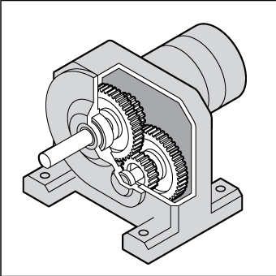

Interlocked physical barriers
An interlock guard is connected to the plant's operational controls so that the plant is prevented from operating until the guard is closed. The guard cannot be opened or removed until the dangerous parts of the machine have fully come to rest. In Figure 2, the hinged top guard on the food mixer has a positively operating insertion key which automatically cuts off the plant's power when the lid is opened or removed. This allows the blades to come to rest. If the moving parts do not stop immediately once the power is cut off, then a guard should be designed to delay release of the locking mechanism until the moving parts have stopped.
Figure 2 Food mixer with interlocking guard

Physical barriers fixed in position
Physical barriers that are securely fixed in position should be easy to remove and replace but only with the aid of a special tool, such as a spanner, Allen key or similar tool, and only when the machine is not in operation (see Figure 3). Devices such as wing nuts or wedge inserts, which can be operated using fingers or become stuck, should not be used.
Figure 3 Fixed guard on rotating shaft or coupling
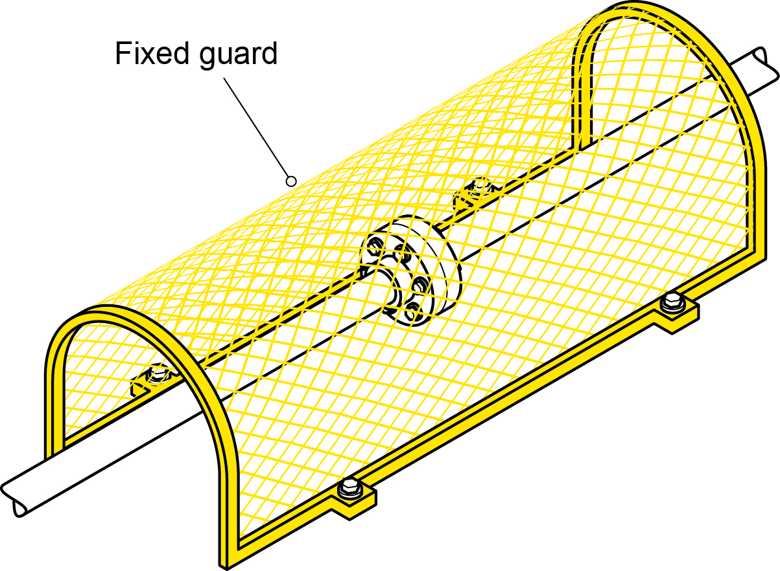
Physical barriers such as perimeter fences securely fixed in position may prevent access to dangerous areas. Any access points, for example gates and doors, should be secured with a lock and key or an interlocking system (see Figure 4). Isolation procedures may be necessary where there is a danger of machines activating while a person is inside the barrier. For example, when an interlocked door is accidentally closed the machine should not automatically restart.
Figure 4 Perimeter fence guard with fixed panels and interlocking access door
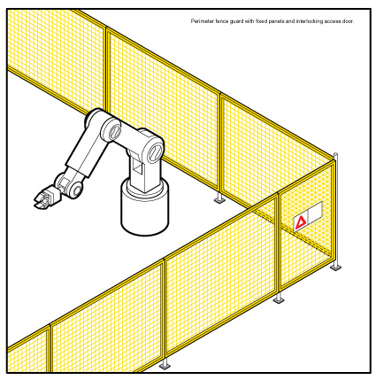
Adjustable guarding incorporates movable sections or panels of the guard to allow materials to be fed into the guarded area while still preventing physical contact (see Figure 5).

Figure 5 Self-adjusting guard for a drop saw
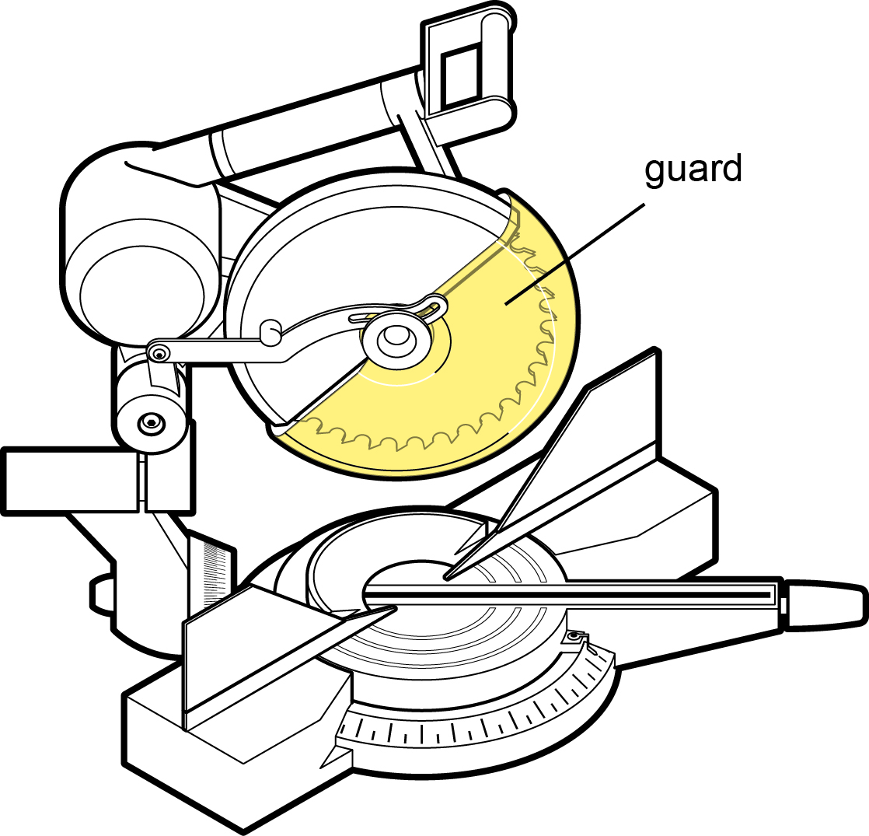
Physical barrier guarding should be strong enough to resist normal wear and shock that may arise from failure of the parts or processes being guarded; and to withstand prolonged use with a minimum of maintenance.

Presence sensing systems
If physical guards are not reasonably practicable, then a presence sensing system can be used to control the risk. These systems detect when a person (or part of a person’s body) enters the danger zone and stops the machine. Photoelectric light beams, laser scanners and foot pressure mats are examples of these type of guards. They rely on sensitive trip mechanisms and the machine being able to stop quickly, which may be assisted by a brake (see Figures 6 and 7).
Effective presence-sensing safeguard systems require the selection of a trip device appropriate for the work being done, and the correct location of beams with light activated devices, taking into account speed of entry and machine stopping time.
Figure 6 Paper cutting guillotine with a combination of guards including a photoelectric light curtain

Figure 7 Pressure sensitive mat

Environmental factors
When using a guard you should consider the environment in which it may be used. Some examples of poor guard selection include: guards on high frequency welders that become electrically charged, heating of guards in hot processes and wire mesh guards on machines emitting splashes.
If a guard is likely to be exposed to corrosion, you should consider corrosion-resistant materials or surface coatings.

Colour coding
It is good practice for all guards to be painted the same colour. For example:
- use high visibility yellow, provided it is different to the plant’s colour, so that it can be clearly seen when a guard has been removed or when it is not in its proper place, and
- paint the surfaces behind the guard a contrasting or bright colour so that when the guard is removed, the exposed colour is clearly visible and it is easy to identify that the guard has been removed, alerting workers to possible danger.
For some types of plant, it may be necessary to choose colours that contrast with workpieces, where these need to be visible through the guarding.

Removal of guarding
If any type of guarding is removed for the purposes of maintenance or cleaning, it must be replaced before the plant is put back into normal operation. The plant should not be able to restart unless the guarding is in place. When removing guarding, eliminate the energy source by disconnecting the power supply or by locking out motive power sources.

4.2 Operator controls
Regulation 210: A person with management or control of plant at a workplace must ensure that any operator controls are:
- identified so as to indicate their nature, function and direction of operation
- located so they can be readily and conveniently operated
- located or guarded to prevent unintentional activation, and
- able to be locked into the “off” position to enable disconnection from energy sources.
Badly designed operator controls can lead to unintentional and unsafe operation of plant. For example, a control for setting the speed on a saw should not be a simple slider or rotary control that may be accidentally adjusted during operation. It should be graduated in fixed lockable steps.
Operator control devices should be designed:
- to enable the plant to be ‘fail safe’. For example, when hand pressure is released on a lever controlling up and down movement, the lever will return to the neutral position and movement will stop
- to be within easy access of the operator
- so the intended function can be easily read and understood, especially in the case of dials and gauges
- so the movement of the control is consistent with established convention, for example anticlockwise to open, clockwise to close
- so the desired effect can only occur by intentional operation of a control, for example provision of a starting control
- to withstand the rigours of normal use, undue forces and environmental conditions,
- so they are located outside danger zones, and
- so they are readily accessible for maintenance.

4.3 Emergency stops
Regulation 211: If the design of plant at a workplace includes an emergency stop control, the person with management or control of the plant must ensure that:
- the stop control is prominent, clearly and durably marked and immediately accessible to each operator of the plant
- any handle, bar or push button associated with the stop control are coloured red, and
- the stop control cannot be adversely affected by electrical or electronic circuit malfunction.
Where plant is designed to be operated or attended by more than one person and more than one control is fitted, the multiple controls must be of the “stop and lock-off” type so that the plant cannot be restarted after a stop control has been used unless each activated stop control is reset.
Emergency stop devices should not be the only method of controlling risks. They should be designed as a back-up to other control measures.
Once engaged, the emergency stop controls should remain that way. It should only be possible to disengage the emergency stop controls by a deliberate action. Disengaging the emergency stop control should not restart the plant. It should only allow the normal starting sequence to be activated.
In the case of plant or parts of plant designed to work together, stop controls (including the emergency stop control) should be capable of stopping the plant itself as well as all the equipment interrelated to its operation, where continued operation of this related equipment may be dangerous.
Figure 8 Emergency stop button
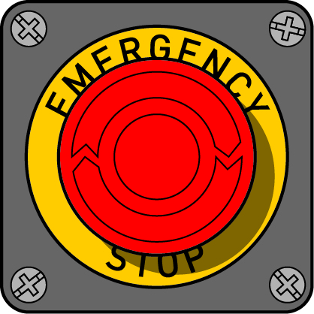

4.4 Warning devices
Regulation 212: A person with management or control of plant at a workplace must ensure that an emergency warning device is positioned on the plant to ensure that the warning device will work to best effect.
Regulation 215: If there is a possibility of the plant colliding with pedestrians or other powered mobile plant, the person with management or control of the plant must ensure that the plant has a warning device that will warn persons who may be at risk from the movement of the plant.
Warning devices should be used where there is a likelihood of moving plant colliding with other plant or workers in the vicinity of the plant. There are a number of warning devices that can be fitted to moving plant to alert the operator and others in the workplace.

Automatic audible alarms
Automatic audible alarms are usually fitted to warn of forward or reversing movement. These alarms emit an intermittent sound which is activated when the gear or drive lever is engaged.
If automatic audible alarms are used, the sound should be distinct and clearly audible only in the hazard area. If several items of plant are using the same warning device it may be difficult for workers to be aware of which item of plant is moving or is about to move. It is also possible that workers will become desensitised to the sound. For this reason it may be more effective to combine audible alarms with other warning devices, such as flashing lights.

Motion sensors
Motion sensors also warn with sound. They are sensitive to movement and are activated by motion in the required direction. These devices are suitable for plant that moves suddenly in any direction, such as rollers, bulldozers, excavators, boom lifts or scissor lifts.
Motion sensor alarms usually deactivate after a short time. They should not be deactivated if the operator has restricted vision when reversing.

Lights
Lights are usually used to warn of forward and reversing movement. These lights are wired to operate continuously or in hazard mode by flashing, usually when reversing. They generally work when the gear or drive lever is engaged.
It is important to choose the intensity and colour of the lights appropriate to your workplace to ensure that the moving plant can be seen. For example, an orange warning light may be suitable inside a warehouse but may not be seen in sunlight.

Flashing lights
Rotary flashing lights are coloured revolving lights that are usually mounted in a prominent place, such as the top of a vehicle cabin. They can be wired to operate continuously or activated by a switch. They are suitable to be used on any items of plant that moves in the workplace, such as forklifts or skid steer loaders.
Flashing lights may not be suitable for plant that:
- is stationary for long periods of time, and
- operates in restricted areas, such as trucks travelling on defined site roads.

Percussion alarms
Percussion alarms are mechanical devices that are fitted to an axle or gear shift. When plant moves, a cam raises a hammer that drops repeatedly onto a bell or sounding plate. These alarms are relatively cheap to install, however they require regular maintenance to ensure they continue functioning effectively.

Radio sensing devices
Radio sensing devices activate when the operator selects reverse. A light and alarm sounds inside the cabin to alert the operator if a pedestrian is within a predetermined distance from the rear of the plant.

Air horns
Horns are suitable for powered mobile plant with long breaking distances, such as trucks. Some large workplace or sites may require a truck to “stop and sound horn before continuing”.

4.5 Isolation of energy sources
An isolation procedure is a set of predetermined steps that should be followed when workers are required to perform tasks such as maintenance, repair, installation and cleaning of plant.
Isolation procedures involve the isolation of all forms of potentially hazardous energy so that the plant does not move or start up accidentally. Isolation of plant also ensures that entry to a restricted area is controlled while the specific task is being carried out.
The lock-out process is the most effective isolation procedure. The process is as follows:
- shut down the machinery and equipment
- identify all energy sources and other hazards
- identify all isolation points
- isolate all energy sources
- control or de-energise all stored energy
- lock out all isolation points
- tag machinery controls, energy sources and other hazards, and
- test by ‘trying’ to reactivate the plant without exposing the tester or others to risk. Failure to reactivate the plant means that the isolation procedure is effective and that all stored energies have dissipated. This may require further measures to safely release these energies, for example hydraulic or pneumatic pressure, suspended weight or compressed springs.
In order for the isolation procedure to be effective, you should identify all energy sources likely to activate the plant or part of it and isolate or de-energise these to avoid the plant being inadvertently powered. Energy sources include:
- electricity (mains)
- battery or capacitor banks
- solar panels
- fuels
- heat
- steam
- fluids or gases under pressure (water, air, steam or hydraulic oil)
- stored energy (e.g. compressed springs)
- gravity, and
- radiation.
In order to isolate plant you should use a device that effectively locks out the isolation points. These devices include switches with built-in locks and lock-out circuit breakers, fuses and valves. Other devices include chains, safety lock-out jaws (also known as hasps) and safety padlocks.
When isolating an energy source you should use a lock that allows one or more padlocks to be fitted. If more than one person is working on the plant at the same time, you should ensure that each worker is able to attach a padlock to the device (see Figure 9). This will prevent access to the energy sources while the work is being carried out.
Figure 9 Example of lock-out with a tag and the padlocks of two workers
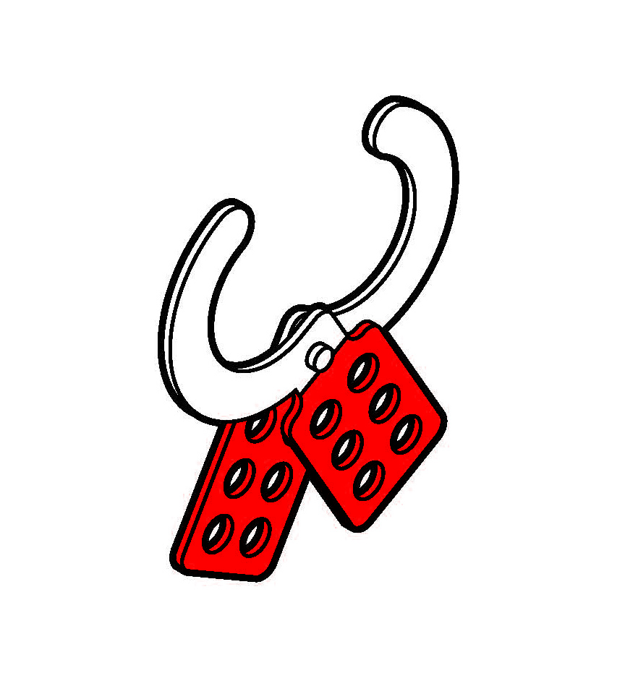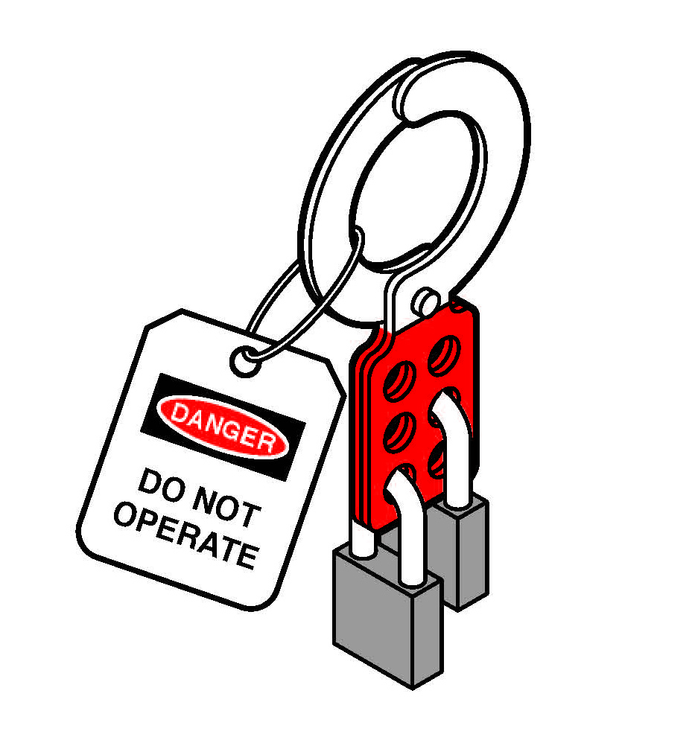
Another way to allow multiple locks to be used is to have one padlock on the isolation point, with the keys locked in a box that has been locked separately by each worker.
Each worker involved in the maintenance, cleaning or repair of the plant should have a lock, tag and key for each isolation point. There should be no duplicate key for any lock, except a master key that is kept in a secure location and should only be used in an emergency.
If more than one energy source needs to be isolated to enable safe shut-down of the plant, the single key to each lock-out device should be held by the same person.
Tags should only be used as a means of providing information to others at the workplace. A tag should not be used on its own as an isolation device; only a lock is effective at isolating the energy source.

5. PLANT REGISTRATION
Schedule 5 of the WHS Regulations requires certain plant designs and items of plant to be registered (registrable plant). Schedule 5 is reproduced at Appendix A.
You must not allow the use of any registrable plant in the workplace if it has not been registered.

5.1 Design and altered design registration
You must register a plant design if:
- it has not already been design registered, or
- you alter the plant design by modifying the plant and the alterations to the design may affect health and safety.
In order to register a plant design, the design must be verified by a design verifier who must provide a statement that the design has been produced in accordance with published technical standards or engineering principles specified by the designer. Examples of published technical standards are provided at Appendix C.
A design can only be verified by a person who is eligible to be a design verifier under the WHS Regulations. The types of people who would be competent to verify the design of plant may include someone who:
- has educational or vocational qualifications in an engineering discipline relevant to the design to be verified
- has knowledge of the technical standards relevant to the design to be verified
- has the skills necessary to independently verify that the design was produced in accordance with the published technical standards and engineering principles used in the design, and
- is certified by a body that is accredited or approved by the Joint Accreditation System—Australia and New Zealand or an equivalent overseas body to undertake conformity assessments of the design against the relevant technical standards.
For example, this could include someone who is registered on the National Professional Engineers Register administered by the Institution of Engineers Australia and is determined by that Institution to be competent to design or inspect the relevant type of plant, or is a member of the Institution of Engineers Australia with the status of Chartered Professional Engineer.
When registering a plant design, the WHS regulator will issue a plant design registration number. This number must then be given to the manufacturer, importer or supplier of plant. These duty holders must ensure that the design registration number is provided to the person with management or control of plant at the workplace.
The person with management or control of plant at the workplace must then ensure that the design registration number is kept readily accessible in the vicinity of the plant at all times. A reliable way to achieve this is to permanently mark the design registration number on the plant.

Changes to design registration
If a registered plant design is altered so as to require any new risk control measures, the altered design must be registered.

5.2 Item registration
A person with management or control of an item of plant specified in Part 2 of Schedule 5 of the WHS Regulations must apply to the WHS regulator to register that item of plant.
In order to have an item of plant registered, the item must be inspected and a statement provided by a competent person stating that the plant is safe to operate. A person is competent to inspect an item of plant if the person has educational or vocational qualifications in an engineering discipline relevant to the plant, or knowledge of the technical standards relevant to the plant to be inspected.
If the design of the plant was also required to be registered, the design registration number must be included with the application.

Duration of registration
Registration of an item of plant applies for five years, and takes effect on the day the registration is granted and expires five years after that date.

Once the item of plant is registered
When the item of plant is registered, the WHS regulator will issue a registration document. This document will list the name of the registration holder, any associated business name, the registration number and the date of effect of the registration. This document must be kept and made available for any inspection required under the Act.
If it is lost, stolen or destroyed, you will need to apply to the WHS regulator that registered the plant for a replacement document as soon as possible, outlining the reasons for needing a replacement.
The WHS regulator may impose any conditions it considers appropriate on the registration of the plant including conditions in relation to the use and maintenance of the plant, record keeping or provision of information to the WHS regulator.
You must ensure that the item registration number is permanently marked on the item of plant in a location that is readily accessible. It will generally be a simple task to mark large items of plant with the item registration number by either etching the number in place or by fixing the number in place on a plate in a position that will not lead to damage or removal over time.
On some items, such as a tower crane that may comprise many parts assembled in a variable configuration to suit a particular site, it may not be feasible to mark each component of the plant. In such cases the item registration number should be marked on those components that are readily accessible and able to be seen when the crane is fully assembled.

Registration renewal
The registration of the item of plant will expire exactly five years from the date that the registration is granted. To renew the registration for the item of plant you must apply to the WHS regulator before the registration expires.

Changes to item registration
If there is any change to any information provided at the time of item registration, or in relation to the registration itself, you have 14 days to advise the WHS regulator of the change. This must be done in writing. In particular, you must provide written notice to the regulator if:
- the item of plant is altered to the extent that it requires new risk control measures
- the item of plant is usually fixed but has been moved, and
- the registration holder no longer has management or control of the item of plant.

6. KEEPING RECORDS
Regulation 237: A person with management and control of plant must keep a record for plant that requires design or item registration including records of all tests, inspections, maintenance, commissioning, decommissioning, dismantling and alterations of the plant.
These records must be kept for the period the plant is used or until the person relinquishes control of the plant.
The records must be available for inspection under the WHS Act and be made available to any person to whom the person relinquishes control of the plant, for example if you sell the plant, those records should be transferred to the person who purchased the plant.
If there is a presence sensing safeguarding system at a workplace the person with management or control of the plant must keep a record of safety integrity tests, inspections, maintenance, commissioning, decommissioning, dismantling or alterations for the life of the plant or until control is relinquished or in any other case for 5 years.
While you must keep records associated with plant requiring design or item registration, it is good practice to keep records for other types of plant in your workplace. Keeping records of the risk management process demonstrates potential compliance with the WHS Act and Regulations. It also helps when undertaking subsequent risk assessments.
Records on items of plant that may be kept could include:
- the unique plant identification number
- plant design registration information
- relevant data from commissioning
- compliance statements and/or test certificates
- manufacturer’s specifications and user manuals
- results of inspections
- results of tests on the plant including safety devices (for example, protective earth continuity tests, testing of mechanical guarding, stop time measurement)
- information on maintenance and major repairs carried out
- information on major modifications
- information on use that deviates from intended operating or design conditions
- results of risk assessments carried out on plant
- information, instruction and training provided to workers, and
- competencies of operators.

APPENDIX A – REGISTRABLE PLANT
List of plant requiring registration of design in Schedule 5 (Part 1) of the WHS Regulations
- Pressure equipment, other than pressure piping, and categorised as hazard level A, B, C or D according to the criteria in Section 2.1 of AS 4343-2005: Pressure equipment – hazard levels.
- Gas cylinders covered by Section 1 of AS 2030.1-2009: Gas cylinders - General requirements.
- Tower cranes including self-erecting tower cranes.
- Lifts including escalators and moving walkways.
- Building maintenance units.
- Hoists with a platform movement exceeding 2.4 metres, designed to lift people.
- Work boxes designed to be suspended from cranes.
- Amusement devices covered by Section 2.1 of AS 3533.1-2009: Amusement rides and devices - Design and construction except amusement devices noted below.
- Passenger ropeways.
- Concrete placing booms.
- Prefabricated scaffolding.
- Boom-type elevating work platforms.
- Gantry cranes with a safe working load greater than 5 tonnes or bridge cranes with a safe working load of greater than 10 tonnes, and any gantry crane or bridge crane which is designed to handle molten metal or Schedule 11 hazardous chemicals.
- Vehicle hoists.
- Mast climbing work platforms.
- Mobile cranes with a rated capacity of greater than 10 tonnes.
The plant listed as requiring design registration does not include:
- a heritage boiler
- any pressure equipment–other than a gas cylinder–excluded from the scope of AS 1200:2000: Pressure equipment–see section A1 of Appendix A to AS/NZS 1200:2000
- a crane or hoist that is manually powered
- a reach stacker
- an elevating work platform that is a scissor lift or a vertically moving platform
- a tow truck
- certain amusement devices including:
- class 1 devices
- playground devices
- water slides where water facilitates patrons to slide easily, predominantly under gravity, along a static structure
- wave generators where patrons do not come into contact with the parts of machinery used for generating water waves, and
- inflatable devices, or other than inflatable devices–continuously blown–with a platform height of 3 metres or more.

List of plant items requiring registration in Schedule 5 (Part 2) of the WHS Regulations
- Boilers categorised as hazard level A, B or C according to criteria in Section 2.1 of AS 4343-2005: Pressure equipment - hazard levels.
- Pressure vessels categorised as hazard level A, B or C according to the criteria in Section 2.1 of AS 4343-2005: Pressure equipment - hazard levels, except for gas cylinders; LP Gas fuel vessels for automotive use, and serially produced vessels.
- Tower cranes including self-erecting tower cranes.
- Lifts including escalators and moving walkways.
- Building maintenance units.
- Amusement devices covered by Section 2.1 of AS 3533.1-2009: Amusement rides and devices - Design and construction except amusement devices noted below.
- Concrete placing booms.
- Mobile cranes with a rated capacity of greater than 10 tonnes.
The plant listed as requiring item registration does not include:
- any pressure equipment–other than a gas cylinder–excluded from the scope of AS/NZS 1200:2000: Pressure equipment–see section A1 of Appendix A to AS/NZS 1200:2000
- a crane or hoist that is manually powered
- a reach stacker
- certain amusement devices including:
- class 1 devices
- playground devices
- water slides where water facilitates patrons to slide easily, predominantly under gravity, along a static structure
- wave generators where patrons do not come into contact with the parts of machinery used for generating water waves, and
- inflatable devices, or other than inflatable devices–continuously blown–with a platform height of 3 metres or more.

APPENDIX B – HAZARD CHECKLIST
Description of plant: ____________________________________________________
Activities (e.g. use, cleaning and maintenance): _____________________________________________
Assessed by: __________________________________________________________________
Date:__________________________________________________________________________
‘Yes’ to any of the following indicates the need to implement appropriate control measures
Entanglement | YES | NO
Can a person’s hair, clothing, gloves, necktie, jewellery, cleaning brush or rag become entangled with moving parts of the plant?
Crushing | YES | NO
Can anyone be crushed due to:
- material falling off the plant?
- uncontrolled or unexpected movement of the plant?
- lack of capacity for the plant to be slowed, stopped or immobilised?
- the plant tipping or rolling over?
- parts of the plant collapsing?
- coming into contact with moving parts of the plant during testing, inspection, operation, maintenance, cleaning or repair?
- being thrown off or under plant?
- being trapped between the plant and materials or fixed structures?
- other factors not mentioned?
Cutting, Stabbing or Puncturing | YES | NO
Can anyone be stabbed or punctured due to:
- coming in contact with sharp or flying objects?
- coming in contact with moving parts during testing, inspection, operation, maintenance, cleaning or repair?
- the plant, parts of the plant or work pieces disintegrating?
- work pieces being ejected?
- the mobility of the plant?
- uncontrolled or unexpected movement of the plant?
- other factors not mentioned?
Shearing | YES | NO
Can anyone’s body parts be sheared between two parts of the plant, or between a part of the plant and a work piece or structure?

Striking | YES | NO
Can anyone be struck by moving objects due to:
- uncontrolled or unexpected movement of the plant or material handled by the plant?
- the plant, parts of the plant or work pieces disintegrating?
- work pieces being ejected?
- mobility of the plant?
- other factors not mentioned?
High Pressure Fluid | YES | NO
Can anyone come into contact with fluids under high pressure, due to plant failure or misuse of the plant?
Electrical | YES | NO
Can anyone be injured by electrical shock or burnt due to:
- the plant contacting live electrical conductors?
- the plant working in close proximity to electrical conductors?
- overload of electrical circuits?
- damaged or poorly maintained electrical leads and cables?
- damaged electrical switches?
- water near electrical equipment?
- lack of isolation procedures?
- other factors not mentioned?
Explosion | YES | NO
Can anyone be injured by explosion of gases, vapours, liquids, dusts or other substances, triggered by the operation of the plant or by material handled by the plant?
Slipping, Tripping and Falling | YES | NO
Can anyone using the plant, or in the vicinity of the plant, slip, trip or fall due to:
- uneven or slippery work surfaces?
- poor housekeeping e.g. offcuts, cables, hoses obstructing walkways, spills not cleaned up?
- obstacles being placed in the vicinity of the plant?
- other factors not mentioned?
Can anyone fall from a height due to:
- lack of a proper work platform?
- lack of proper stairs or ladders?
- lack of guardrails or other suitable edge protection?
- unprotected holes, penetrations or gaps?
- poor floor or walking surfaces, such as the lack of a slip-resistant surface?
- steep walking surfaces?
- collapse of the supporting structure?
- other factors not mentioned?
Ergonomic | YES | NO
Can anyone be injured due to:
- poorly designed seating?
- poorly designed operator controls?
- high forces?
- repetitive movements?
- awkward body posture or the need for excessive effort?
- vibration?
- other factors not mentioned?
Combination of hazards | YES | NO
Can anyone be injured due to unexpected start-up, unexpected over-run/over-speed (or similar malfunction) from:
- failure/disorder of the control system, for example a hydraulic system?
- restoration of energy supply after an interruption?
- external influences on electrical equipment?
- other environmental factors (gravity, wind, etc.)?
- errors in the software?
- errors made by the operator?
Other hazards | YES | NO
Can anyone be injured due to:
- noise?
- inadequate or poorly placed lighting?
- entry into any confined spaces of the plant?
- failure to select plant that is suitable for its intended use?
- contact with hot or cold parts of plant?
- exposure to hazardous chemicals, radiation or other emissions released by the plant?
- lack of operator competency?
- other factors not mentioned?

APPENDIX C – EXAMPLES OF TECHNICAL STANDARDS
The following table is a list of published technical standards that provide guidance on the design, manufacture and use of certain types of plant. These technical standards provide guidance only and compliance with them does not guarantee compliance with the WHS Act
and Regulations in all instances. This list is not exhaustive.

Plant Description | Reference Number | Standard Title | Design | Make | Use
Amusement Structures | AS 3533 | Amusement Rides and Devices | • | • | •
Cranes including hoists and winches | AS 1418 (Series) | Cranes Including Hoists and Winches | • | •
Cranes including hoists and winches | AS 4991 - 2004 | Lifting devices | • | • | •
Cranes including hoists and winches | AS 2550 (Series) | Cranes – Safe use |  |  | •
Conveyers | AS 1755 - 2000 | Conveyers - Safety requirements | • | • | •
Electrical installation | AS 3000 | Electrical installation (known as the Aust/NZ wiring rules) |  |  | •
Electrical installation within an industrial plant | AS/IEC 60204.1 | Safety of machinery: Electrical equipment of machines-General requirements | • | •
Earthmoving machinery | AS 2294.1 | Earth-moving machinery – Protective structures - General | • | •
Earthmoving machinery | AS 2958.1 | Earth-moving Machinery – Safety –Wheeled machines-Brakes | • | • | •
Earthmoving machinery | ISO 6165 | Earth-moving machinery – Basic types – Identification and terms and definitions | •
Earthmoving machinery | ISO 6746-1 | Earth-moving machinery - Definitions of  dimensions and codes - Part 1: Base machine | •
Earthmoving machinery | ISO 6746-2 | Earth-moving machinery - Definitions of  dimensions and codes - Part 2: Equipment and attachments | •
Earthmoving machinery | ISO 7133 | Earth-moving machinery - Tractor-scrapers – Terminology and commercial specifications | •
Explosive Powered tools | AS/NZS 1873 (Series) | Power-actuated (PA) hand-held fastening tools. | • | • | •
Hand-held electric tools | AS/NZS 60745 | Hand-held motor operated electric tools – Safety – General requirements | • | • | •
Fall arrest | AS/NZS 1891.1 | Industrial fall-arrest systems and devices - Harnesses and ancillary equipment | • | •
Fall arrest | AS/NZS 1891.4 | Industrial fall-arrest systems and devices - Selection, use and maintenance |  |  | •
Fall arrest | BS EN 1263-1:2002 | Safety nets-Safety requirements, test methods | •
Gas cylinders | AS 2030.1-1999 | Gas cylinders-General requirements (known as SAA Gas Cylinders Code ) | • | •
Gas cylinders | AS 2337.2 -2004 | Gas cylinder test stations |  |  | •
Gas cylinders | AS/NZS 3509 | LP (Liquefied Petroleum Gas) Fuel -Vessels for Automotive Use. | • | •
Industrial (Forklift) trucks | AS 2359 (Series) | Powered industrial trucks | • | • | •
Industrial rope access systems | AS 4488.2-1997 | Industrial rope access systems | • | • | •
Lasers | AS/NZS 2211 (Series) | Safety of laser products | • | • | •
Lasers | AS 2397 | Safe use of lasers in the building and construction industry |  |  | •
Lasers | AS/NZS IEC 60825.1: 2011 | Safety of laser products – Equipment classification and requirements | • | • | •
Lifts | AS 1735 (Series) | Lifts, escalators and moving walks (known as the SAA Lift Code) | • | • | •
Machinery | AS 4024 (Series) | Safety of machinery | • | • | •
Machinery | AS 1657 | Fixed platforms, walkways, stairways and ladders-Design, construction and installation | • | •
Machinery | AS 1788.2 -1987 | Abrasive wheels-Selection, care and use | • | • | •
Machinery | AS 1893-1977 | Code of practice for the guarding and safe use of metal and paper cutting guillotines | • | • | •
Machinery | AS 2661-1983 | Vapour degreasing plant – Design, installation and operation – Safety requirements | • | • | •
Machinery | AS/NZS 3947.3:2001 | Low-voltage switchgear and control gear, switches, disconnectors, switch-disconnectors and fuse combination units | • |  | •
Machinery | AS 61508.6 -2011 | Functional safety of safety related systems | • | • | •
Machinery | AS/IEC 61511 | Functional safety – Safety instrumented system for the process industry sector | • | • | •
Machinery | AS 62061 | Safety of machinery: Functional safety of safety-related electrical, electronic and programmable electronic control systems | • | • | •
Machinery | ISO 13849.1 | Safety of machinery: Safety-related parts of control systems-General principles | • | • | •
Machinery | BS/IEC 6496-2:1997 | Safety of machinery, Electro sensitive protective equipment | • |  | •
Machinery | AS 1121.1:2007 | Agricultural tractor power take-offs - rear-mounted power take-off types 1, 2 and 3 - General specifications, safety requirements, dimensions for master shield and clearance zone | • | •
Machinery | AS 1636 | Agricultural wheeled tractors - Roll-over  protective structures criteria and tests | • | •
Machinery | AS/NZS 2153.1:1997 | Tractors and machinery for agriculture and forestry - Technical means for ensuring safety - General | • | •
Machinery | SAE J167-2011 | Overhead protection for agricultural tractors - Test procedures and performance requirements | • | •
Miniature boilers | AMBSC Code –Part 1 | Copper Boilers - Issue 7-2001 | • | •
Miniature boilers | AMBSC Code –Part 2 | Steel Boilers – Issue 4-1995 | • | •
Miniature boilers | AMBSC Code - Part 3 | Sub-Miniature Boilers – Issue 1-2008 | • | •
Miniature boilers | AMBSC Code – Part 4 | Duplex Boilers – Issue 1-2010 | • | •
Pressure equipment | AS/NZS 1200:2000 | Pressure Equipment | • | • | •
Pressure equipment | AS 2593:2004 | Boilers – Safety management and supervision systems | • |  | •
Pressure equipment | AS 2971:2007 | Serially produced pressure vessels | • | •
Pressure equipment | AS/NZS 3788:2006 | Boiler and pressure vessels – In service inspection |  |  | •
Pressure equipment | AS 3873 :2001 | Boiler and pressure vessels – Operation and maintenance |  |  | •
Pressure equipment | AS 3920.1-1993 | Assurance of product quality – Pressure equipment manufacture | • | •
Pressure equipment | ASME I | Power boilers | • | •
Pressure equipment | ASME II | Materials | • | •
Pressure equipment | ASME V | Non-destructive examination | • | •
Pressure equipment | ASME VIII-1 | Pressure vessels | • | •
Pressure equipment | ASME VIII- 2 | Pressure vessels – alternative rules | • | •
Pressure equipment | ASME VIII-3 | Alternative rules for construction of high pressure vessels | • | •
Pressure equipment | ASME IX | Welding and brazing qualifications | • | •
Pressure equipment | ANSI / NGV-2 | Basic requirement of compressed natural gas vehicle fuel containers | • | •
Pressure equipment | CSA B51 Part 2 | High pressure cylinders for the on-board storage of natural gas as a fuel for automotive vehicles | • | •
Pressure equipment | ISO 11439:2000 | High pressure cylinders for the on-board storage of natural gas as a fuel for automotive vehicles | • | •
Pressure equipment | ISO/EN 13458 (Series) | Cryogenic vessels – Static vacuum insulated vessels | • | • | •
Pressure piping | AS 4041-2006 | Pressure piping | • | •
Machinery guarding | AS 4024 (Series) | Safeguarding of machinery – general principles | • | • | •
Machinery guarding | ISO 12100:2010 | Safety of machinery – General principles for design | • | • | •
Scaffolding | AS/NZS 1576.1:2010 | Scaffolding – general requirements | • | •
Scaffolding | AS 1577-1993 | Scaffold planks | • | •
Scaffolding | AS/NZS 4576 | Guidelines for scaffolding |  |  | •
Ladders | AS/NZS 1892.1/1892.2/1892.3 | Portable ladders | • | •
Spray painting | AS/NZS 4114.1 | Spray painting booths. Part 1: Design, construction and testing | • | • | •
Spray painting | AS/NZS 4114.2 | Spray painting booths. Part 2: Installation and maintenance |  |  | •
Turbines | BS/EN 60593-2:1996 | Rules for steam turbine acceptance tests | •
Turbines | API 612 | Special purpose steam turbines for refinery services | •
Ventilation | AS 1668.2 | The use of ventilation and air conditioning in buildings | • | • | •
Work boxes- crane lifted | AS 1418.17  1996 | Cranes (including hoists and winches) | • | •
Work boxes- crane lifted | AS 2550 | Cranes – Safe use |  |  | •
Work boxes- crane lifted | AS 3860-1991 | Fixed guideway people movers | • | • | •
Work boxes- crane lifted | ISO 2374 | Lifting appliances – Range of maximum capacities for basic models | • | •

Key:

Abbreviations Name
ANSI American National Standards Institute
API American Petroleum Institute
AMBSC Australian Miniature Boiler Safety Committee
AS Australian Standard
ASME American Society of Mechanical Engineers
AS/NZS Australian Standard / New Zealand Standard
BS British Standard
CSA Canadian Standards Association
EN Europaische Norm (European Standard)
IEC International Electrochemical Commission
ISO International Standards Organisation
NZS New Zealand Standards
SAE Society of Automotive Engineers

LIST OF AMENDMENTS

Date | Page Number | Amendments
23 September 2013 | Front cover | Publication date changed from first published date of July 2012 to republished date of September 2013.
23 September 2013 | Whole document | Style and formatting has been reviewed.
23 September 2013 | Appendix A | Appendix A revised in line with Schedule 5 amendments to the WHS Regulations.
23 September 2013 | 3 | Section 3.4 added to Table of Contents.
23 September 2013 | 4 | Wording in paragraph 3 of Scope and application ‘[under development]’ removed.
23 September 2013 | 8 | Wording in fifth paragraph ‘[under development]’ removed.
23 September 2013 | 16-18 | Second hand plant text updated.
23 September 2013 | 27 | Wording in Figure 2 ‘Food mixer with an interlocking arm’ removed.
23 September 2013 | 30 | Wording in Figure 7 ‘Presence – sensing safeguard system’ removed.

